**09-Nov-2022**

Azure Account creation: <https://k21academy.com/microsoft-azure/create-free-microsoft-azure-trial-account/>

Azure Basic Services Understanding:

Azure IAM/Active Directory => User Management | SAAS

Azure Virtual Machine => Server | IAAS

Azure VNet => Cloud network

Azure Storage Account => Online storage

Azure DB => DB servers | PAAS

**10-Nov-2022**

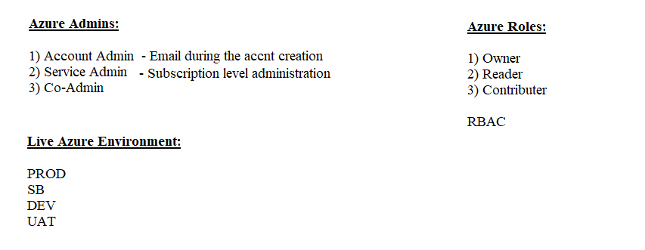

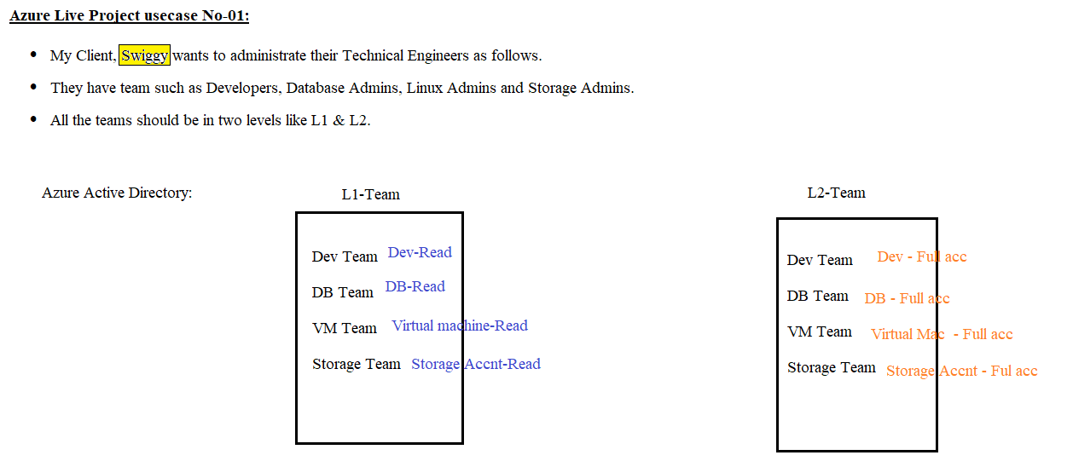

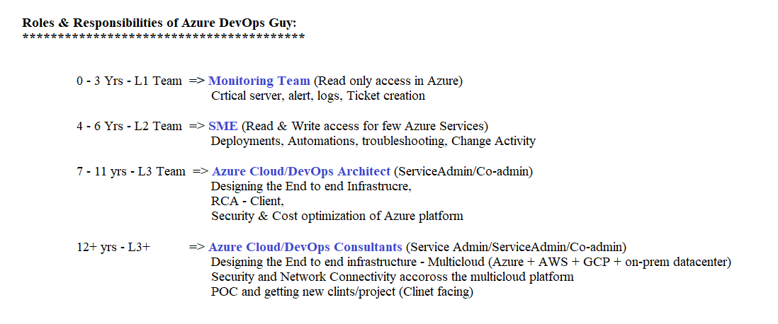

**15-Nov-2022**

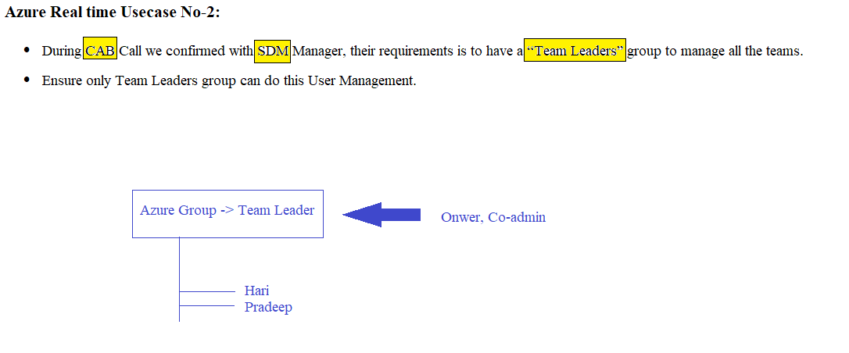

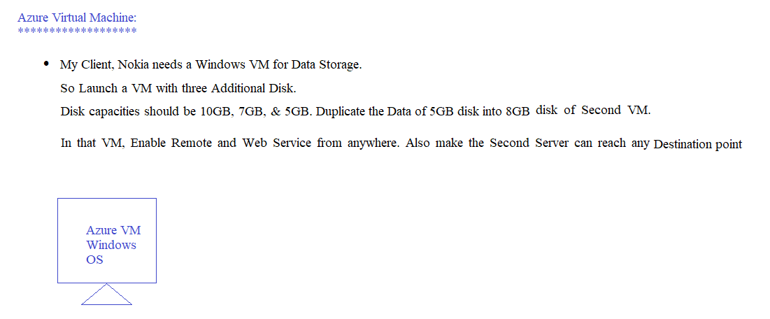

https://azure.microsoft.com/en-us/explore/global-infrastructure/geographies/#geographies

https://learn.microsoft.com/en-us/azure/reliability/availability-zones-overview

**16-Nov-2022**

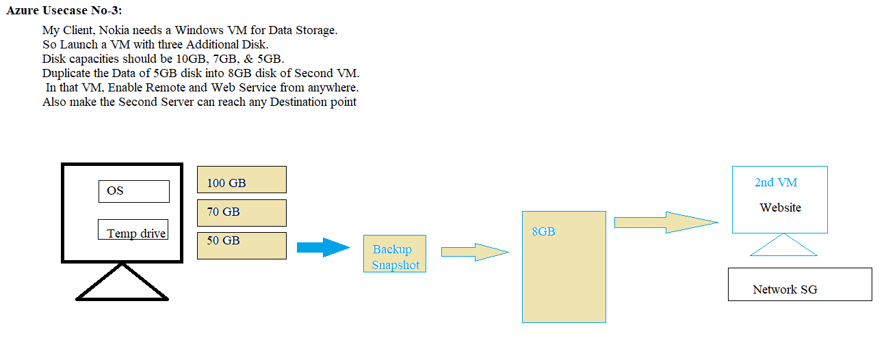

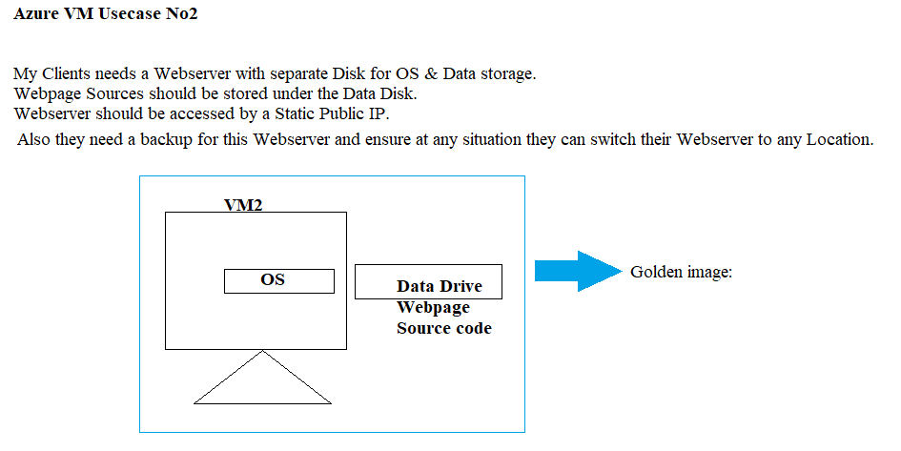

**17-Nov-2022**

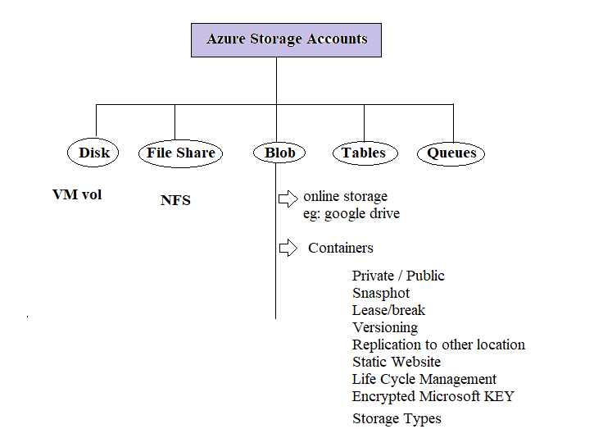

**23-nov-2022**

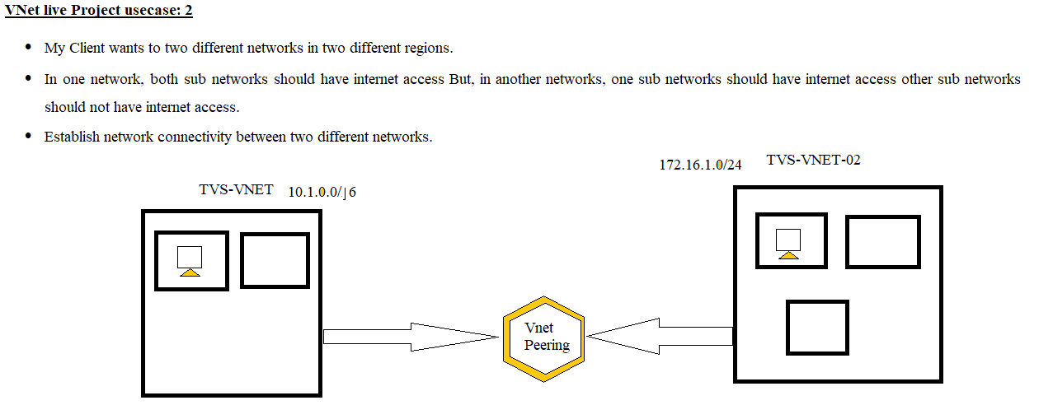

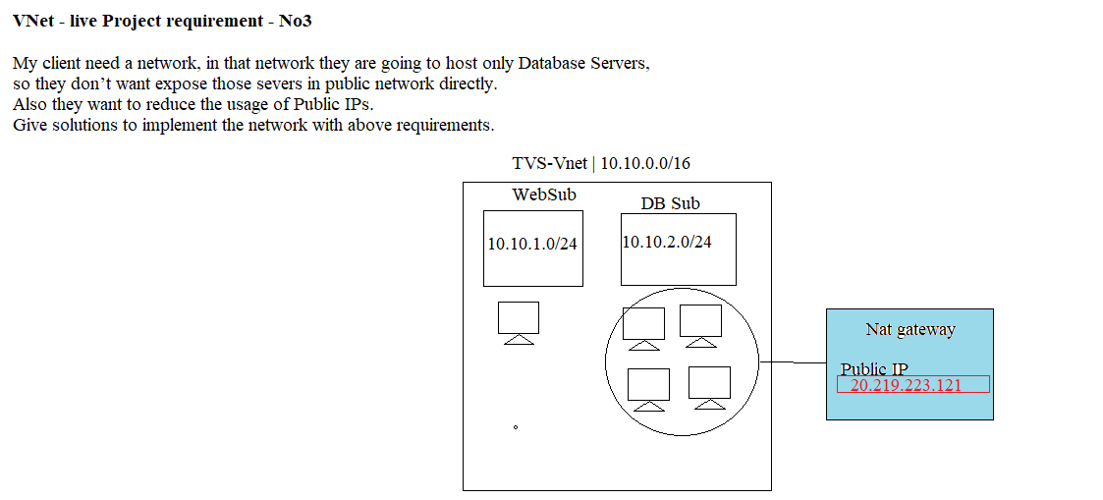

**07-Dec-2022**

**Putty Link:** [**https://the.earth.li/~sgtatham/putty/latest/w64/putty.exe**](https://the.earth.li/~sgtatham/putty/latest/w64/putty.exe)

Linux OS:

*********

RedHat Family

RHEL

Centos

Fedora

Debian Family

Ubuntu

====================

Root => Admin

Linux Basic Commands:

*********************

Clear => To clear the Putty shell interface

sudo su => We can switch the user as Root

cd / => change the directory

ls or ll => to list the available contents inside of the current directory

mkdir <fol_name> => To create new directory

touch <file_name> => To create a new file

Package Manager in Linux:

**************************

apt-get update

apt-get install nginx

Services Management in linux:

*****************************

systemctl status nginx

systemctl start nginx

systemctl stop nginx

Hosting the web application in Linux:

*************************************

cd /var/www/html



**Repo URL:** <https://github.com/hariharanjenkin/webapp.git>

**08-Dec-2022**

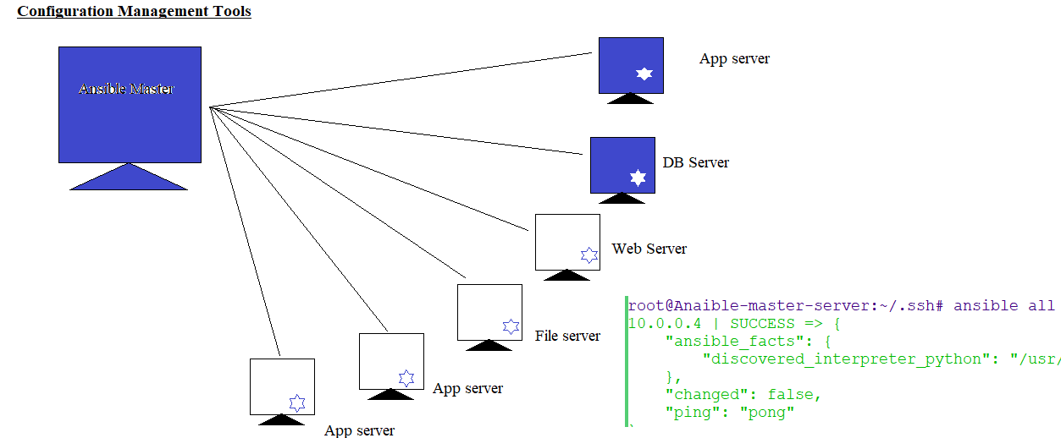

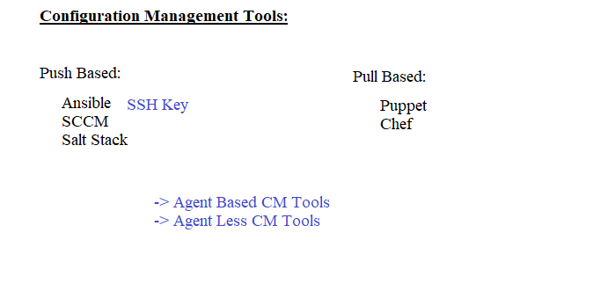

**20-Dec-2022**

**Installation of Docker in ubuntu:**

https://www.digitalocean.com/community/tutorials/how-to-install-and-use-docker-on-ubuntu-20-04

========================

**Docker Basic Commands:**

docker images => To get the list of available images

docker pull <image_name> => To download the images from Docker_hub to local docker host

docker ps => To list the running containers

docker ps -a => To list the Stopped containers

docker run -it <name_continer> <image_name> => To create a new container

docker stop <container_id>

docker start <container_id>

docker restart <container_id>

docker rm <container_id>

docker attach <container_id> => To login to the containers

Ctrl + P + Q => To logout from the containers

**26-Dec-2022**

az aks get-credentials --resource-group <rg_Name> --name <cluster_Name>

Kubectl get nodes => To list the worker nodes

kubectl get pod => To list the pods

kubectl run <name_pod> --image <image_name> => Create new POD

kubectl exec -it <name_pod> -- /bin/bash => To login inside of the pod

=======================================================

Creating the POD through Deployment:

************************************

kubectl get deployment

kubectl create deployment <name_deploy> --image <image_name> => To create the deployment

kubectl delete pod <pod_name> => To delete the POD

kubectl describe pod <pod_name> => describe to know more details about pod

kubectl describe deployment <name_deploy> => describe to know more details about deployment

=======================================================

Resizing the POD's:

*******************

hari [ ~ ]$ kubectl edit deployment test-deployment01

deployment.apps/test-deployment01 edited

hari [ ~ ]$

hari [ ~ ]$ kubectl get deployment

NAME READY UP-TO-DATE AVAILABLE AGE

test-deployment01 5/5 5 5 14m

hari [ ~ ]$ kubectl get pod

NAME READY STATUS RESTARTS AGE

test-deployment01-57b654966f-cq4gz 1/1 Running 0 30s

test-deployment01-57b654966f-fnz68 1/1 Running 0 30s

test-deployment01-57b654966f-g9h4m 1/1 Running 0 30s

test-deployment01-57b654966f-v2kmw 1/1 Running 0 30s

test-deployment01-57b654966f-xcsl9 1/1 Running 0 10m

hari [ ~ ]$ kubectl get replicaset

NAME DESIRED CURRENT READY AGE

test-deployment01-57b654966f 5 5 5 15m

=======================================================

Working with the Namespaces:

****************************

PROD

SB

Dev

kubectl get namespace

kubectl create ns <ns_name>

hari [ ~ ]$ kubectl run testpod-001 --image nginx -n prod

pod/testpod-001 created

hari [ ~ ]$ kubectl run xyzzzz-001 --image nginx -n prod

pod/xyzzzz-001 created

hari [ ~ ]$ kubectl run abcccc --image nginx -n sb

pod/abcccc created

hari [ ~ ]$

hari [ ~ ]$ kubectl get pod

NAME READY STATUS RESTARTS AGE

test-deployment01-57b654966f-fnz68 1/1 Running 0 12m

test-deployment01-57b654966f-g9h4m 1/1 Running 0 12m

test-deployment01-57b654966f-xcsl9 1/1 Running 0 22m

hari [ ~ ]$ kubectl get pod -n prod

NAME READY STATUS RESTARTS AGE

testpod-001 1/1 Running 0 55s

xyzzzz-001 1/1 Running 0 42s

hari [ ~ ]$ kubectl get pod -n sb

NAME READY STATUS RESTARTS AGE

abcccc 1/1 Running 0 34s

=======================================================

**02-Jan-2023**

